REDLINE
Medical Supplies & Equipment Trading
ريد لاين للتجارة في المستلزمات والمعدات الطبية

Company Profile
نبذة عن الشركة
RedLine Medical Supplies & Equipment Trading - company, branches, warehouses and operations

Project | Odoo ERP Implementation - Graduation Project (simulation)
Document code | RL-CP-001
Version | 1.0 (final)
Preparation date | 25 October 2026
Business reporting period | 1 May 2026 – 30 September 2026
Target platform | Odoo 19.0 (Enterprise edition assumed)
Prepared by | Mohamed Mahmoud Abdel Bary, Mohamed Essam El-Din Youssef, Ahmed Mahmoud Mohamed, Fathy Adel Fathy, Omnia Haitham
Currency | EGP - Egyptian Pound
Disclaimer: all companies, partners, bank details and transactions in this project are fictional or illustrative simulation data. Nothing in this document claims that the configuration has been installed, imported or tested on a live Odoo server.

Contents
1 | Company at a glance / لمحة سريعة
2 | History and operating context
3 | Business model
4 | Vision and mission / الرؤية والرسالة
5 | Organizational structure
6 | Branches
7 | Warehouse network
8 | Product categories
9 | Target customers
10 | Supplier relationships
11 | Operational scale (five-month simulation)
12 | Management objectives for the Odoo project
13 | Terminology and data caveats
Section numbers are used for cross-references throughout the document set (e.g. 'SSD 4.2' = Solution Design Document, section 4.2).

1. Company at a glance / لمحة سريعة
RedLine Medical Supplies & Equipment Trading is a Cairo-based trading company that imports, distributes and sells medical equipment, consumables, disposables and spare parts to hospitals, clinics, laboratories and healthcare providers across Egypt.
ريد لاين للتجارة في المستلزمات والمعدات الطبية شركة مقرها القاهرة، تعمل في استيراد وتوزيع وبيع المعدات الطبية والمستهلكات والمستلزمات وقطع الغيار للمستشفيات والعيادات والمعامل ومقدمي الرعاية الصحية في مصر.
Item | Detail
Legal name | RedLine Medical Supplies & Equipment Trading
الاسم بالعربية | ريد لاين للتجارة في المستلزمات والمعدات الطبية
Headquarters | 45 Makram Ebeid St, Nasr City, Cairo, Egypt
Email | info@redlinemedical.com.eg
Country / base currency | Egypt / EGP (Egyptian Pound)
Primary business | Trading, importing, distributing and selling medical equipment, consumables, disposables and spare parts
Operating history (simulated) | Five completed months: 1 May 2026 – 30 September 2026
Legal-entity model | One legal company; three operational branches in Cairo; four warehouse locations
Target ERP | Odoo 19.0 (Enterprise edition assumed)

Important. The company, partners, transactions and bank relationships described here form a graduation-project simulation. They are not independently verified real-world records.

2. History and operating context
RedLine is presented as an established trading business that grew from a single sales office in Nasr City into a three-branch operation serving the Greater Cairo region and several governorates. Until the Odoo project the company is assumed to have run on manual processes: spreadsheets for stock cards and customer balances, paper-based purchase and delivery notes, and stand-alone accounting entries (a simulated legacy baseline; no specific legacy software is claimed).
The assumed pain points that motivated the project are: no reliable lot and expiry control for consumables; equipment serial numbers recorded on paper; delayed stock-to-ledger reconciliation; limited credit control for hospitals paying in 45-60 days; and no single view of branch performance.
The simulated trading history used throughout the project covers 1 May 2026 – 30 September 2026, immediately before the project documentation date of 25 October 2026.

3. Business model
Revenue stream | Description | Typical customers | Stock treatment
Medical equipment trading | Capital equipment (MRI, ultrasound, patient monitors, infusion pumps, ECG, defibrillators, hospital beds, oxygen concentrators, autoclaves, surgical sets) | Hospitals, imaging centers, clinics | Serial-number tracked; FIFO valuation
Consumables and disposables | Syringes, masks, gloves, cannulas, IV sets, gauze, sterile kits, tubing, ECG electrodes, defibrillator pads | Hospitals, labs, clinics, retail counter | Lot tracked with expiry; FEFO picking
Spare parts and accessories | Filters, sensors, gaskets, batteries for installed equipment | Hospitals, service engineers, clinics | Untracked or lot tracked (no expiry)
After-sales support | Installation, warranty administration and maintenance contracts (service revenue accounts defined; not simulated) | Equipment buyers | Service products

Margins in the simulation are driven by product type: equipment carries a gross margin of about 20-25% before customer discounts, consumables 30-40% and spare parts 28-35%. Contract discounts of 0-5% are granted to hospital customers. Credit terms of 15-60 days apply to institutional customers; retail counter sales are cash.

4. Vision and mission / الرؤية والرسالة
Vision: To be Egypt's most trusted partner for medical supplies and equipment, known for traceable quality and dependable delivery.
الرؤية: أن تكون الشريك الأكثر ثقة في مصر في المستلزمات والمعدات الطبية، المعروف بالجودة القابلة للتتبع والتسليم الموثوق.
Mission: To supply healthcare providers with authentic, correctly stored and fully traceable medical products, supported by responsive service and transparent commercial terms.
الرسالة: توريد منتجات طبية أصلية ومخزنة بصورة سليمة وقابلة للتتبع بالكامل لمقدمي الرعاية الصحية، مع خدمة سريعة وشروط تجارية واضحة.
Values / القيم: Patient safety first - Traceability - Integrity - Service reliability - Continuous improvement.

5. Organizational structure
The organization is led by a General Manager reporting to the owners. Functional managers (Finance, Sales, Procurement, Warehouse & Logistics, Technical Service) report to the General Manager; branch managers run the three Cairo branches.
Unit | Reports to | Main responsibilities
General Manager / المدير العام | Board / Owners | Overall results, final approvals, credit-limit sign-off
Finance & Accounting Manager / مدير المالية | General Manager | Accounting, VAT, credit control, payment approval, period close
Sales & Marketing Manager / مدير المبيعات | General Manager | Quotations, pricing, tenders, key accounts
Procurement Manager / مدير المشتريات | General Manager | Vendor selection, RFQs, imports, purchase orders
Warehouse & Logistics Manager / مدير المخازن | General Manager | Four warehouses, FEFO, delivery, recall readiness
Quality & Compliance Officer / مسؤول الجودة | Warehouse & Logistics Manager | Incoming inspection, quarantine decisions, traceability
Technical Service Manager / مدير الخدمة الفنية | General Manager | Installation, warranty, spare-parts service
Branch Managers (3) / مديرو الفروع | General Manager | Branch administration, retail and sales office

The full organizational chart is provided in Organization_and_Accounting_Charts.xlsx (sheet 'Organizational Structure').

6. Branches
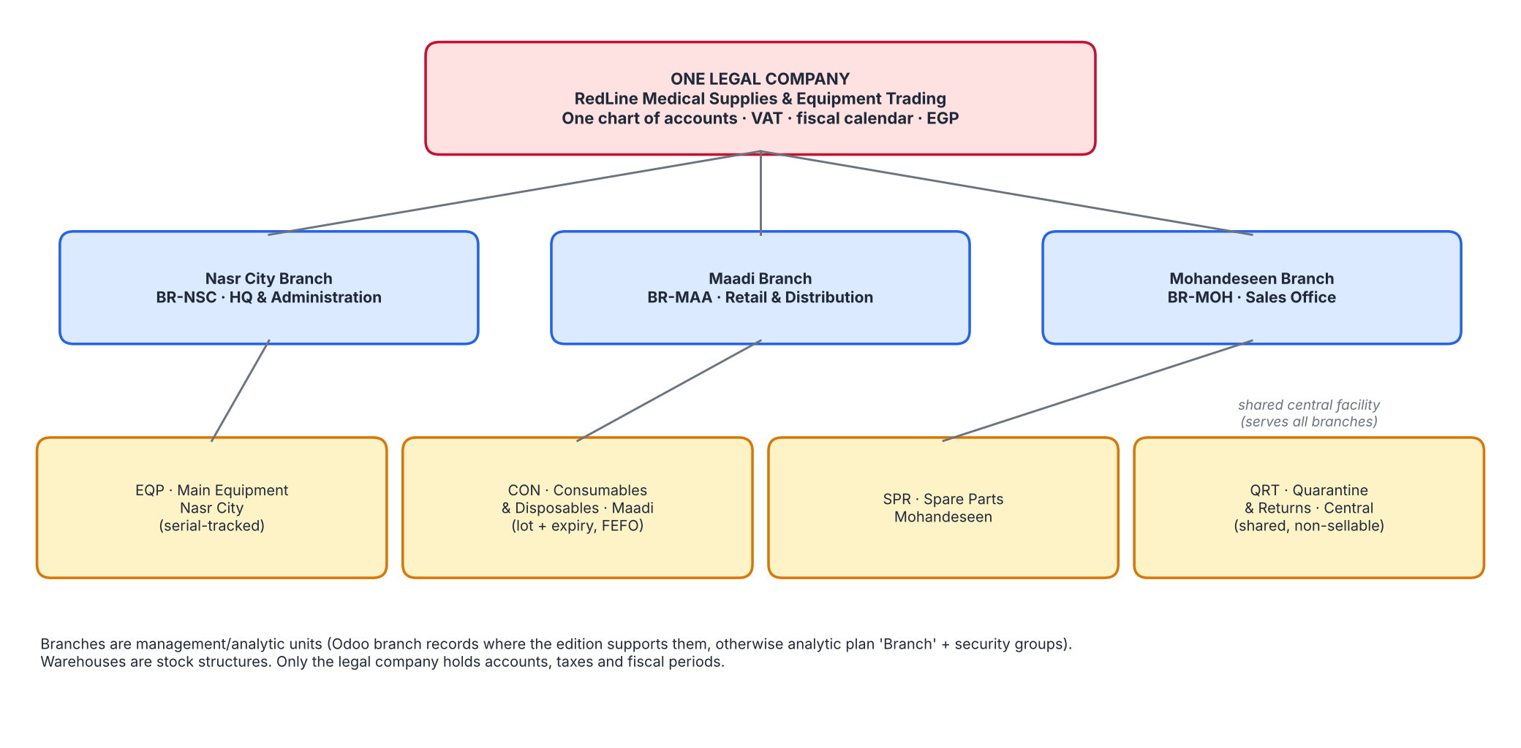
Figure 1 - Company, branches and warehouses (single legal company)
Code | Branch | الفرع | Role | Address
BR-NSC | Nasr City Branch | فرع مدينة نصر | Main Headquarters and Administration / المقر الرئيسي والإدارة | 45 Makram Ebeid St, Nasr City, Cairo, Egypt
BR-MAA | Maadi Branch | فرع المعادي | Retail and Distribution / التجزئة والتوزيع | 18 Road 9, Maadi, Cairo, Egypt
BR-MOH | Mohandeseen Branch | فرع المهندسين | Sales Office / مكتب المبيعات | 22 Syria St, Mohandeseen, Greater Cairo, Egypt

The Nasr City address is the registered headquarters. Maadi and Mohandeseen street addresses are plausible illustrative addresses created for this project.

7. Warehouse network
Code | Warehouse | المخزن | Branch | Purpose
EQP | Main Equipment Warehouse | مخزن المعدات الرئيسي | BR-NSC | Receiving, storage and dispatch of capital medical equipment (serial-tracked)
CON | Medical Consumables & Disposables Warehouse | مخزن المستهلكات والمستلزمات الطبية | BR-MAA | Lot- and expiry-tracked consumables; FEFO picking; retail counter supply
SPR | Spare Parts Warehouse | مخزن قطع الغيار | BR-MOH | Spare parts, filters and batteries for installed equipment
QRT | Quarantine & Returns Warehouse | مخزن الحجر الصحي والمرتجعات | BR-NSC | Isolation of failed-inspection, returned, damaged and near-expiry stock pending disposition

Distinguishing the concepts. A branch is a management and reporting unit; a warehouse is a stock structure with its own locations and routes; a stock location is a node inside a warehouse; the legal company is the single entity that holds the chart of accounts, taxes and fiscal calendar. The Quarantine & Returns warehouse is a shared central facility administered by the Nasr City branch.

8. Product categories
Category | Examples (simulated catalogue) | Tracking | Home warehouse
Medical equipment | MRI 1.5T, ultrasound, patient monitor, infusion pump, ECG, defibrillator, hospital bed, oxygen concentrator, autoclave, surgical instrument set | Serial number | EQP
Medical consumables | Syringes, masks, nitrile gloves, IV cannulas, IV sets, gauze, sterile surgical kits, silicone tubing, ECG electrodes, defibrillator pads | Lot (+ expiry for sterile/perishable items) | CON
Spare parts | HEPA filters, SpO2 sensors, autoclave gaskets, monitor batteries | None / lot (no expiry) | SPR

The simulated catalogue contains 24 products (10 equipment, 10 consumables, 4 spare parts). The full list with Arabic names, costs, prices and barcodes is in Products_and_Inventory_Data.xlsx.

9. Target customers
Segment | Examples (illustrative) | Typical terms
Hospitals | Al Salam Teaching Hospital, Nile Valley Medical Center, Delta Care Hospital, Alexandria Coastal Hospital, Upper Egypt Medical Complex, Maadi Pediatric Hospital, Red Sea Emergency Hospital | 30-60 days, contract discounts 2-5%
Clinics | Nasr City Family Clinics, New Cairo Women's Health Clinic | 15 days
Laboratories and imaging | Heliopolis Diagnostic Laboratories, Giza Advanced Imaging Center | 30-60 days
Healthcare providers | Zagazig Dialysis Center | 30 days
Retail / individuals | Walk-in customers at the Maadi counter | Cash

All customer names are fictional or clearly illustrative and are not claimed to be real institutions.

10. Supplier relationships
Vendor | Type | Terms | Main products
Helios Medical Systems GmbH / هيليوس ميديكال سيستمز | Manufacturer (illustrative) | 60 days | DEF, ECG, INF, MON, PAD
Orient Imaging Technologies Co. / أورينت لتقنيات التصوير | Manufacturer (illustrative) | 60 days | MRI, USG
MediPlast Industries Egypt / ميدي بلاست الصناعية مصر | Local Manufacturer (illustrative) | 30 days | BED, GAU, IVS, MSK, SYR
Pharos Surgical Supplies / فاروس للمستلزمات الجراحية | Local Distributor (illustrative) | 30 days | CAN, ECE, GLV, KIT, SUR
Anatolia Biomed Distribution / أناضول للتوزيع الطبي | International Distributor (illustrative) | 45 days | AUT, OXY, TUB
CareTech Spare Parts Trading / كير تك لتجارة قطع الغيار | Local Distributor (illustrative) | 30 days | BAT, FIL, GSK, SPO

Vendors are illustrative manufacturers and distributors (international and local). No claim is made that any is a verified authorized distributor; authorization status is a field on the vendor record to be verified before go-live.

11. Operational scale (five-month simulation)
Indicator | Value
Reporting period | 1 May 2026 – 30 September 2026
Sales orders / delivery orders | 87 / 139
Customer invoices (posted in period) / credit notes | 82 / 9
Net invoiced sales before returns (excl. VAT) | EGP 31,077,427.94
Net sales after credit notes | EGP 30,233,232.24
Cost of goods sold | EGP 23,902,966.00
Gross margin | 20.9%
Purchase orders / vendor bills | 27 / 28
Inventory value at 30-Sep-2026 | EGP 24,536,323.00
Receivables at 30-Sep-2026 | EGP 29,532,073.42
Payables at 30-Sep-2026 | EGP 2,662,739.04
Lot-tracked batches / serial-tracked units | 42 / 186

Reading the numbers. Revenue is dominated by one large capital-equipment sale (an MRI system, EGP 23,438,252 net, August) to an imaging center. Excluding this one-off sale, net sales are about EGP 6,794,980 over five months. Management KPIs should be read with this concentration in mind.

12. Management objectives for the Odoo project
- Single source of truth for products, partners, stock and accounting across three branches and four warehouses.
- Lot, serial and expiry traceability with FEFO picking, expiry alerts and recall support.
- Controlled quarantine handling of returned, damaged, failed-inspection and near-expiry goods.
- Automated inventory valuation and COGS with reconciled stock-to-ledger at every month-end.
- Credit control: limits, ageing and approval workflow for hospital customers.
- Branch-level sales and margin visibility; management KPI dashboard.
- Bilingual (Arabic/English) documents with correct RTL printing.

13. Terminology and data caveats
- Simulated data: all transactions are generated by a deterministic model; no live Odoo import or test took place.
- VAT 14%: an assumed standard rate for the simulation; exemptions and e-invoicing must be confirmed by a tax advisor.
- Chart of accounts: a proposed company-specific chart, not an official Egyptian statutory chart; review by a qualified Egyptian accountant is required.
- Bank accounts: CIB and NBE are simulated relationships with masked placeholder numbers.

